We Can All Reduce Flooding in The Rouge River
Have you noticed that our rain patterns have changed in Southeast Michigan? Those of you that have had your basement flood are saying “heck yes!” Climate change has significantly increased the frequency and intensity of flooding in the Rouge River watershed and Southeast Michigan. Warmer temperatures lead to more moisture in the atmosphere, resulting in heavier rainfall events and more frequent downpours. This overwhelms outdated drainage systems, leading to flooding. In addition, warmer winters cause snow to melt earlier, leading to rapid runoff and increased flows in the Rouge River. This can exacerbate flooding, especially when combined with heavy rainfall.
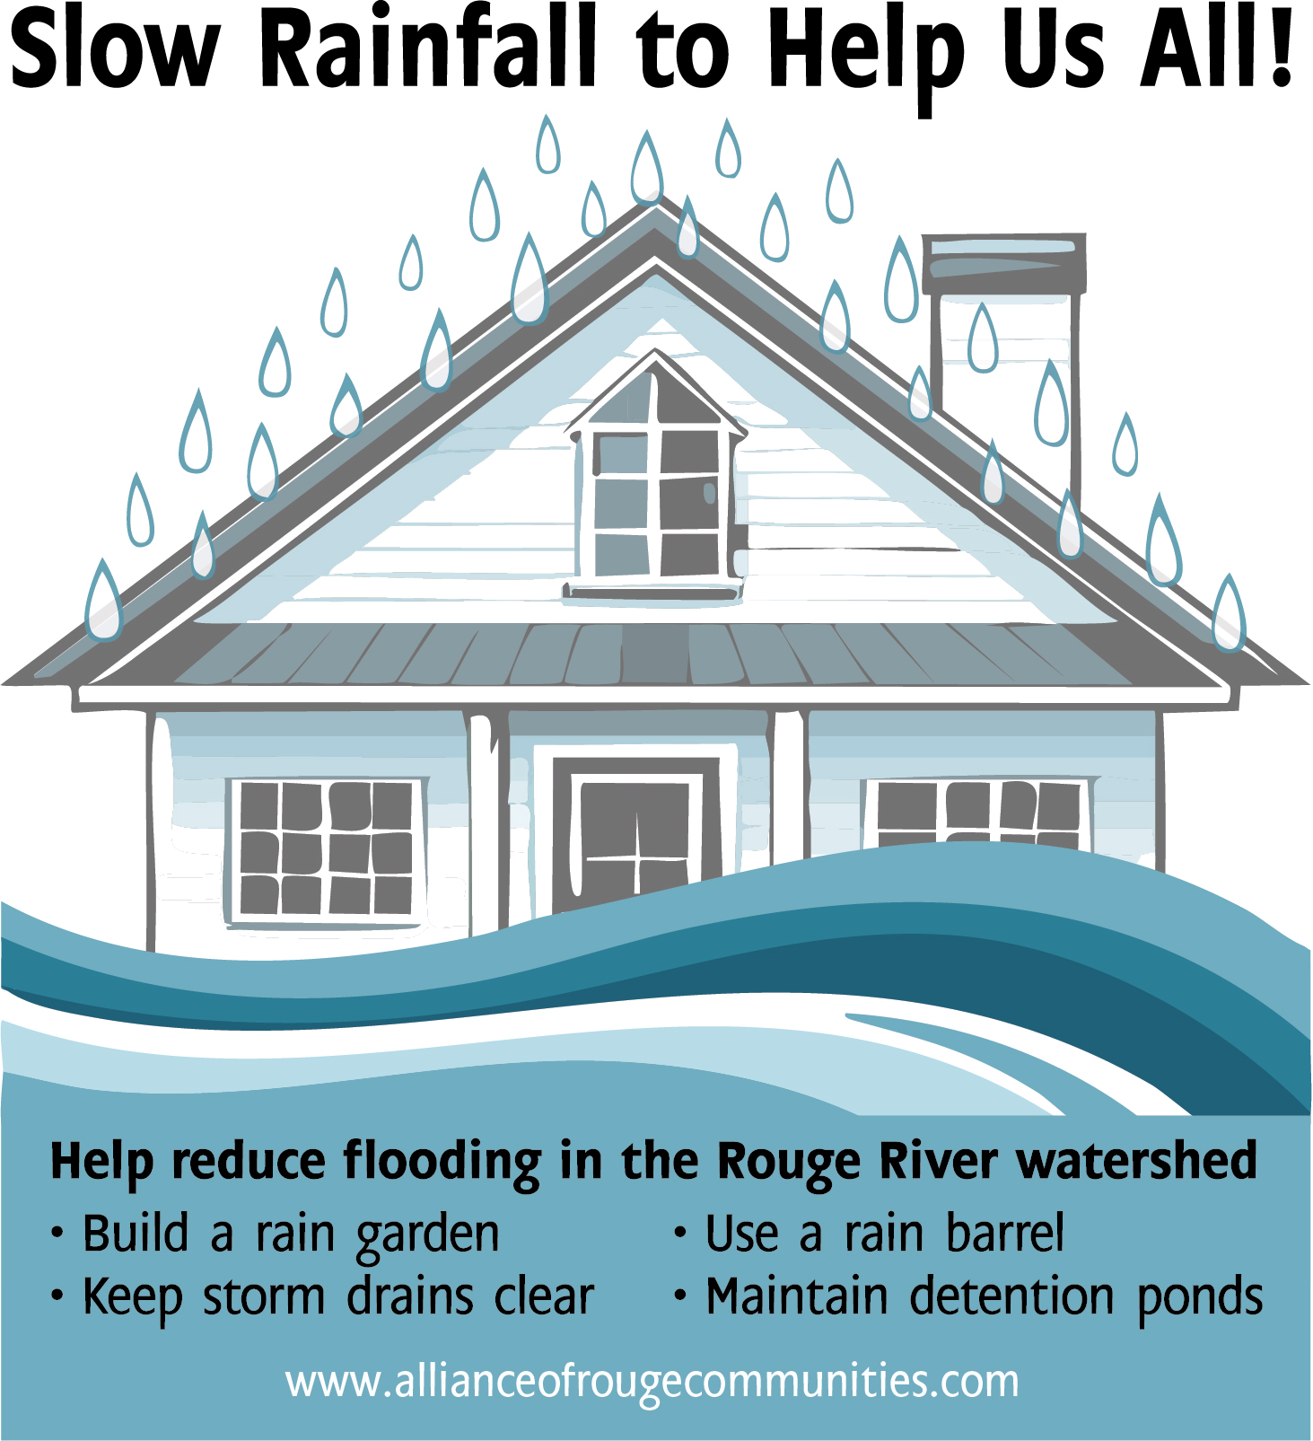
A lot of us know the consequences of the increased rainfall and flooding we have had over the last several years. These include significant damage to homes, businesses, and infrastructure; road closures and disruption to transportation and other essential services; damage to crops and disruption to supply chains which affect the local economy; and even an increase in breeding grounds for mosquitoes.
Communities within the Rouge River watershed are looking at ways to fund and invest in infrastructure upgrades, such as improved drainage systems and flood barriers. They are also looking at ways to improve ordinances and master plans. Additionally, sustainable land use practices and green infrastructure are being implemented. All of these are being incorporated to help reduce the impact of flooding across the watershed.
You can be part of the solution as well! If you live in a subdivision with detention ponds, making sure that they are maintained and working properly will reduce flooding in your neighborhood. Also make sure the storm drains on your street are clear of debris that could block the drain. Consider building rain gardens and planting trees in your yard, which help slow the rainfall, allowing it to soak into the soil instead of entering the storm drain system. Rain barrels are also a great way to reduce the amount of rain entering the Rouge River and provide the homeowner with free water for your yard and garden.
Visit the Alliance of Rouge Communities website to learn more ways you can reduce flooding and protect water quality in the Rouge River at: https://www.allianceofrougecommunities.com/steward.html

